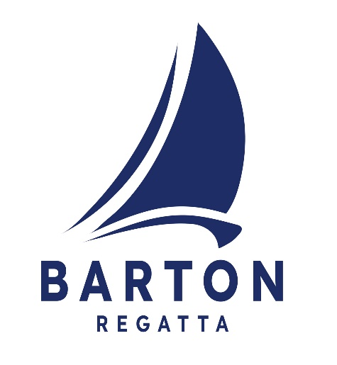
Barton Open Regatta 2024
Due to the logistics of giving a briefing with the number of boats we have, please take this missive as your briefing.
The main communication will be via WhatsApp. There is a QR code in various places to join that group.
Sailing
The Barton Regatta Committee wish for this event to be friendly and safe so please look out for each other and especially the juniors, who are increasing in number, and we wish to encourage them and not scare them.
Please ensure you have read and understood our sailing instructions, on the Barton Regatta page of the NPC website, taking particular note of:
- The starting sequences are all published on the website to make it easier to follow and for you to know which is your class flag for that race, start times may vary.
- Please take note of what constitutes a round. There is an explanation on the website with the sailing instructions.
- The “Dolphin Mark”
- Personal flotation for dinghies
- Start lines and when a round starts/ finishes
- Only River Cruisers take time penalties, all other craft will abide by RRS rule 44.1
- We will not be flying flag I therefore rule 30.1 ( round the ends ) will not apply.
- We will try to issue the courses on the WhatsApp but this may not be possible
- If there is one general recall that start goes to the back of the series. The race will then be black flagged for the second start.
- The finish line is always from the pontoon except in the pursuit race.
We will be running the starting sequence as last year. Each start will have the following sequence, these are explained on the website:
- 5 minutes to go – One sound signal – class flag goes up
- 4 Minutes to go – One sound signal – Blue Peter goes up
- 1 Minute to go – Bell sounds – Blue Peter comes down
- Start – One sound signal , if all clear , class flag comes down
This is a very tight programme of race starts therefore the starting raft team will not be able to respond to individual requests. All questions should be directed through WhatsApp or come to the pontoons. The starting raft will not be calling individual sail number of boats over the line.
River Cruisers will be given a ribbon to fly denoting which start they are in, they will also have a class flag the same colour as their ribbon.
Split start sailors please note that the splits will be published as sail numbers written on white boards on both the pontoons and the starting raft. These will be published an hour before the first race in the series and will not change after this point. River Cruisers will have to come to the pontoon to collect their coloured ribbon.
Any additional entries will be added in where necessary. We will endeavour to keep the starts down to the fewest boats as we can. If you are not sure of your start just come and ask us.
We reserve the right to disqualify any individual breaking the sailing instructions or treating volunteer staff in an unacceptable way. If you have an issue please come and talk to us gently and quietly and we will endeavour to help you.
Other
We will have tea and cake on the go all day. If you don’t want our tea please come and have takeaway cake.
Both the club and the staithe have limited capacity for rubbish disposal, so please could you take as much rubbish home with you as possible. If you do have to dispose of rubbish please could this be done in the bins in Cox’s boat yard, not the staithe bins.
Please don’t block access to the water fill point at the staithe.
We have a raffle on behalf of local charities, last year we raised a lot of money so we will be doing this again.
If you have not bought tickets for the barn party ( via Webcollect) there may still be a few left, please some and see us on the pontoon. The party will be in Cox’s boat shed on the staithe.
We will have a bring your own BBQ on the pontoons Sunday. If you wish to cook your food on the NPC BBQ please book a slot on webcollect. This enables us to help the flow of cooking your food.
Please take great care and drive slowly when moving around the broad, there are a great many youngsters about and we don’t want any accidents.

Thank you for your corporation and have a great regatta.

The Regatta Committee

