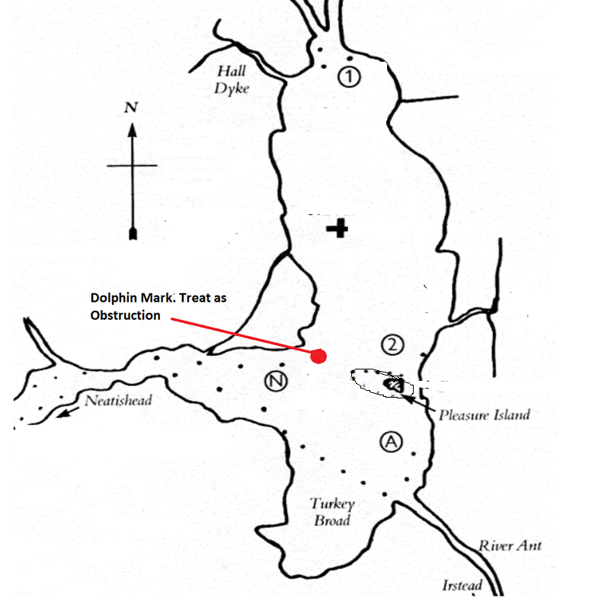

Finish line

Finid

**D**

Start line

**2**