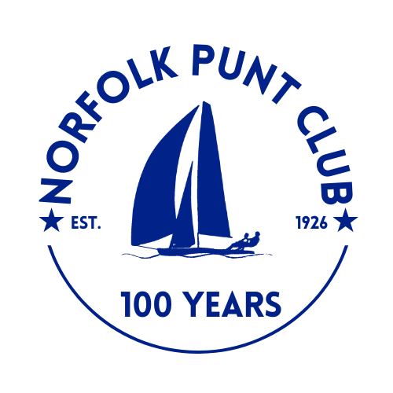
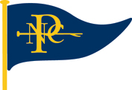

Athene Cup

Held around Thurne Mouth

Hosted by the Norfolk Punt Club

Saturday the 3rd October 2026

The Norfolk Punt Club is looking forward to welcoming club and visiting Norfolk Punts

to Thurne Mouth, for the Athene Cup

Notice of Race

- Event Information
- Hosted by the Norfolk Punt Club on the River Thurne on Saturday 3rd October 2026
- The racing is weather dependent. Please check on the NPC WhatsApp as in the event of bad weather it may be cancelled at short notice.
- Due to this the entry fee of £10 for Athene Cup should be made on the day in cash.
- Entries via WebCollect by the end of Thursday 1st October.
- Minimum of 4 entries for the race to proceed.
- Tow available from Barton Turf leaving at 9am or launch / recovery available from Bureside Holiday Park Dyke, Boundary Road, Great Yarmouth, NR29 3BW
- The briefing will be on Saturday at 12:00 noon. The race will start at 12.30pm and finish around 3.30pm.
- The buoys will be laid near Upton Dyke, St Benets and Womack Water. The exact course and position will be decided on the day.
- The start sequence will be a 10 minute, 5 minute and 1 min bell.

- Eligibility
- Open to all Norfolk Punt Boats
- Non NPC members welcome
- Entrants are sailing for the Blackbird Trophy (first over the water) and the Athene Cup (first on handicap)
- All boats must sail with their correct sail number on their mainsail and spinnaker. If that is not the case you will not be eligible to win a trophy.
- There is strictly no sailing in the dyke.

- Rules
- The race will be sailed in accordance with the RYA Rules and the Norfolk Punt Club Sailing Instructions
- Punts will be sailing on their handicap
- Protests must be lodged within 15 minutes of the final boat finishing
- All visiting competitors will be deemed temporary members of the Norfolk Punt Club during the event and as such shall abide by the club’s rules.

- Prize Giving
- Prize giving will commence around 3.45 pm subject to the completion of any protest hearings
- Overall results will be published on the Norfolk Punt Club website.

