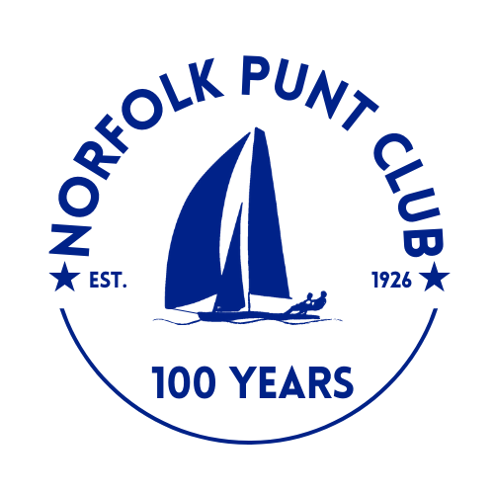
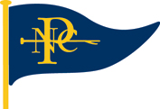

Norfolk Punt Championships

Held at Barton Broad

Hosted by the Norfolk Punt Club

Saturday and Sunday the 22nd and 23rd August 2026

The Norfolk Punt Club is looking forward to welcoming club and visiting Norfolk Punts

to Barton for a weekend of racing for the National Championships

Notice of Race

- Event Information
- Hosted by the Norfolk Punt Club on Barton Broad on Saturday 22nd and Sunday 23rd August 2026
- Tow outs from the NPC moorings, Barton Turf, will be available at 10.30am on Saturday and 10.00am on Sunday
- The briefing will be on Saturday at 11:00am on the NPC pontoon, Barton Broad
- The start sequence will be a 10 minute and a 5 minute with the first start at 12 noon on Saturday
- Entries will cost £20 for the weekend. To be made via Webcollect https://webcollect.org.uk/npc until Friday 21st August at 8am or on the day in cash on the pontoon by 11am
- Tea and cake will be served from 1pm at normal NPC prices
- Drinks Party for competitors and a guest on Saturday 22nd August at 8 Bittern Close, Barton Turf from 6.30-8.30pm

- Eligibility
- Open to all Norfolk Punt boats
- Non-members welcome
- Entrants are sailing for the Punt Championship Cup, Hardchine Trophy, Cuckoo Cup, Progress Challenge Cup and the Broads Haven Trophy

- Rules
- The race will be sailed in accordance with the RYA Rules and the Norfolk Punt Club Sailing Instructions
- Punts will be sailing on their handicap as published by the Norfolk Punt Sailors Association
- Protests must be lodged within 15 minutes of the final boat finishing
- 4 out of 5 races to count
- All visiting competitors will be deemed temporary members of the Norfolk Punt Club during the event and as such shall abide by the club’s rules.

- Prize Giving
- Prize giving will commence around 1.45 pm on Sunday subject to the completion of any protest hearings. Overall results will be published inside the Kon-Tiki hut at the end of prize giving and will also be available for viewing on the Norfolk Punt Club website.

